Hinxworth Village Hall 17th – 19th October

Cabaret Weekend Rally No 18

Grass pitches Post Code SG7 5HL

Directions From A1M north or south take the Langford / Hinxworth turning. Follow signs to Hinxworth on entering Hinxworth, turning into Francis Road, signs to Village Hall, bear right and you will see the Hall.

Rally Officers Jackie & Malcolm Miller Mob:- 07818 451404
E-mail:- jackie63.miller@mail.com

A. R. Officers T.B.A

Attractions Friday night join us for our first evening of the Cabaret – Sly Fox will entertain us.
Saturday evening we have professional entertainment arranged with a possible American supper.
Watch Facebook and the Herts website for updates

Rally Opens Noon Rally Limit 40 Rally Fee £35.40 plus social tickets

What3Words /// frightens.engages.crowbar

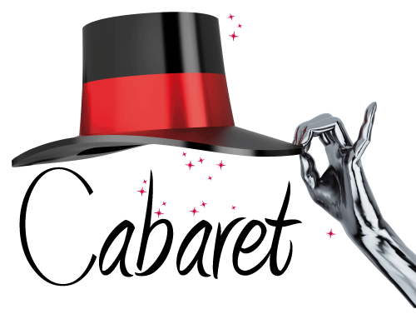

26

