Sywell Aerodrome 19th – 22nd September

SYWELL CLASSIC EVENT Rally No 16

Grass pitches Post Code NN6 0BN

Directions From M1 junction 15 - A45 towards Wellingborough, after 4.5 miles take A5076 Great Billing Way. Next r/about take 3rd exit A4500 after 0.5 miles turn into Ecton Lane, in 2 miles turn right into Overstone Road continue over 3 roundabouts, follow signs to Sywell.

Rally Officers Sandie & Alan Evans
Mob: 07887 541762
E-mail:- sandiejevans@gmail.com

A. R. Officers Jo & Scott Longhurst

Attractions For 9 years running we return to the Sywell Classic, so much to see and do. Every Classic Club will be exhibiting plus an air show during the weekend

Rally Opens Friday 11am Event Limit 200

Event Fee £120 including entry to the shoe both days
Special Booking Form available

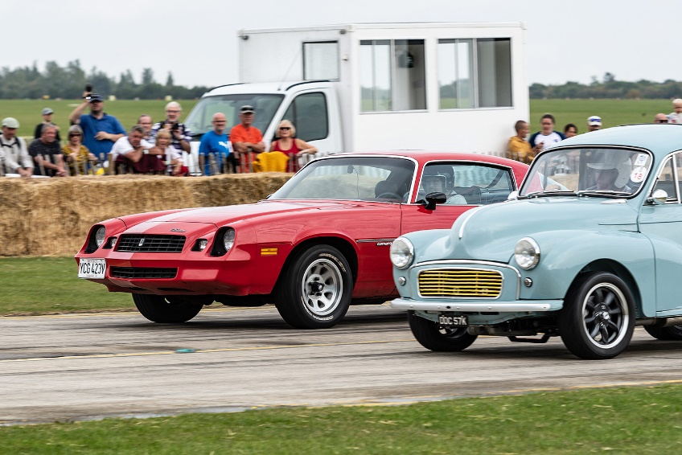

24

