Burnham Market - Norfolk 22nd – 26th August

Burnham Market School Rally No 13

August Bank Holiday Weekend

Grass pitches Post Code PE31 8JA

Directions From Kings Lynn towards Fakenham A148, take B1454 towards Burnham |Market, then the B1155. Friar’s Lane.
Look for the School off the roundabout.

Rally Officers Jean & Steve Hickman Mob:- 075177 08936
Email: jeanhickmam94@gmail.com

A. R. Officers Yvonne & Gordon Pearcy.
Mob: 07957 295079

Attractions Join us for the bank holiday weekend. Socials in the School hall in the evenings. Watch Herts Website for updates and details

Rally Opens Friday Noon Rally Limit 25 Rally Fee £10.50 per night

Please indicate how many nights you wish to stay

What3Words /// grudge.winemakers.speeded

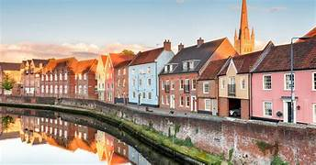

19

