Lilley Village Hall 20th – 22nd June
Cowboys & Indians in the Wild West ! Rally No 9

Grass pitches Post Code LU2 8LH

Directions From Hitchin, take A505 to Luton, bear left onto Offley Hill. Continue to
T- junction and turn right signpost Lilley / Hexton onto Lilley Bottom, straight onto West Street. Site on left 500 yards.

Rally Officers Sandie & Alan Evans
Mob: 07887 541762
E-mail:- sandiejevans@gmail.com

A. R. Officers The Committee

Attractions This is the Chairman’s rally with a twist…
Friday night we have a Western evening, please dress up. Check shirt, jeans and a hat. Indians in war paint !.
The Boules competition will be held on Saturday morning
Saturday evening, we have ‘Splash’ to entertain you with a professional buffet supper.

Rally Opens Friday Noon Rally Fee £30.00 Rally Limit 45

Social Tickets £10.00 per person for both evenings

What3Words /// negotiators.structure.slave

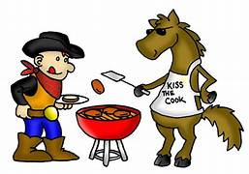

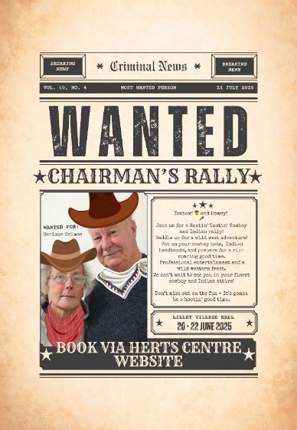

15

