Abingdon - Oxford 23rd – 27th May

Abingdon Cricket Club Rally No 7

Spring Bank Holiday Weekend

Grass pitches Post Code OX14 3HP

Directions On A415 200yds S of Abingdon Bridge, this can easily be missed so would recommend approaching slowly. Entrance is through the cricket club on West side of road to fields at rear Take care not to enter the football club next door. There may be some cricket matches going on during our stay.
Rally Officers Val & Steve Edgar Tel. No: Mobile No: 07956525585
Email:- valcedgar@virginmedia.com

A. R. Officers T.B.A

Attractions This is a lovely location along the River Thames. There is a short walk over the bridge into the town centre, which has lots of nice shops and market square, where they put on activities at certain times. For some reason there are a lot of Barbers, if you fancy a haircut☺. There is a Museum in the old town hall. Frequent bus services into Oxford. Also, there are boat trips to Oxford or you can hire a boat as well nearby and sail down the River Thames yourself. For those who like Wetherspoons, there is one in the town, The Narrows, plus many more lovely eating places.
Rally Opens Friday 11am Rally Limit 50 Rally Fee £13.00 per night
Please indicate how many nights you are staying

What3Words /// bunny.mole.summer
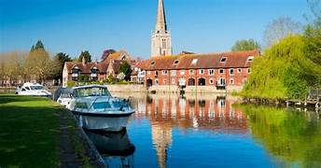

13

