Stockton - Warwick 2nd – 6th May

Blue Lias PH Rally No 5

May Day Bank Holiday Weekend

Grass pitches Post Code CV47 8LD

Directions From the M1, take junction 16 towards Daventry. Then the A425 towards Southam. Onto the A423 Banbury road, then follow the Herts signs to the pub.
Rally Officers Sandie & Alan Evans
Mob: 07887 541762
E-mail:- sandiejevans@gmail.com

A. R. Officers T.B.A

Attractions Friday night -natter and chatter with possibly a game or two.
Saturday night – meal in the pub followed by an evening in the Coleman shelters. Lovely walks along the canal watching the boats go by.

Rally Opens Friday Noon Rally Limit 35 Rally Fee £54.00 for 3 nights
Extra Nights £18.00

What3Words /// spring.portable.unzipped
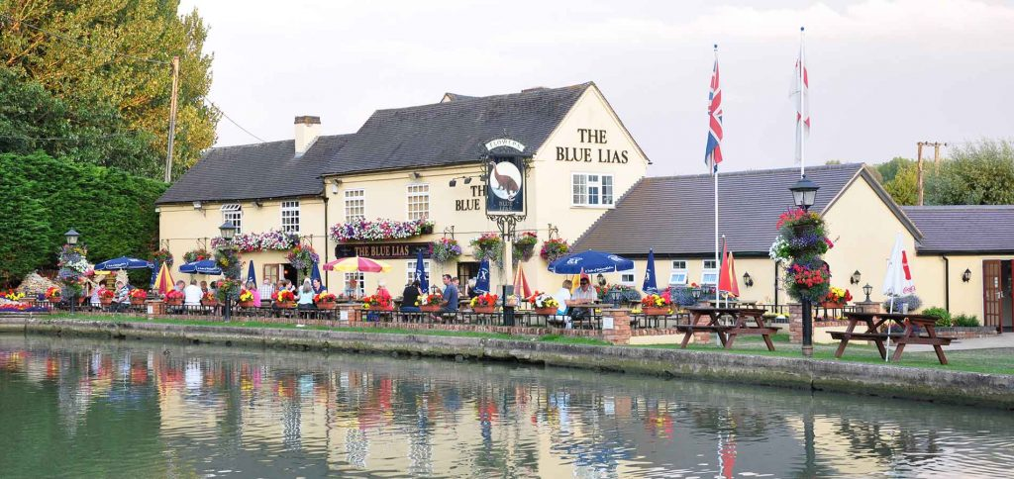

10

