Ridgemont – Beds 26th – 28th July

ROSE & CROWN PH. Rally No11a

Grass pitches Post Code MK43 0TY

Directions From M1 junc 13, take left hand fork towards Ampthill, signed Ridgmont A507. At the r/a take 3rd exit B5704 Station Road. Left on to the High Street. Look for the pub.

Rally Officers Jenny Vardon. Tel: 01763 208832 Mob: 07583 833498
E-mail: jenny.vardon@hotmail.co.uk

A. R. Officers Viv & Mick Lucas

Attractions The Rose & Crown is a beautiful family run country pub set in the little village of Ridgmont.
Maybe a communal BBQ weather premitting

Rally Opens Friday Noon Rally Limit 12 Rally Fee £ 43.00 including EHU

When Booked …………………………………… Booked Online……………………………….

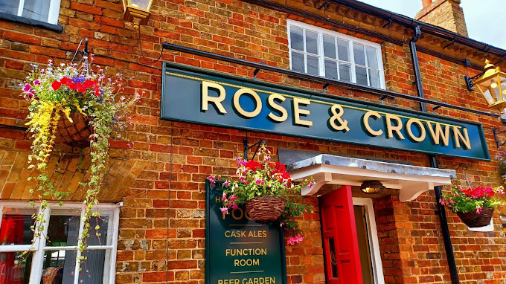

8

